Performance-Based Tests of Function
Name: 2 Minute Walk Test (2MWT)
Domain: Endurance, Aerobic Capacity, Gait, Functional Mobility
Description:
The 2MWT measures the distance a person can walk in two minutes. Rest breaks are allowed if needed. The participant is encouraged to walk as fast as they can, safely, on a flat hard surface for two minutes. Walking aids can be used as needed. The walking aid used during test should be recorded. The tester walks behind subjects to ensure their safety and to minimize the effect of pacing during walking.
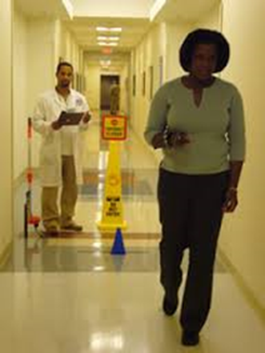
Figure 1. 2 Minute Walk Test
Video: __X_ Yes _____No
https://www.youtube.com/watch?v=qoa0yQBZFs4

Equipment Required/Set-up: Stopwatch, pen and paper, and a mechanical measuring wheel to record each lap
This test will be performed on the walking track in the PT-CTRC. The participant will be instructed to walk on the outside of the track, between the red tape markings.
NOTE: The course may change, but all participants will be asked to walk for 2 minutes regardless of course layout.

Procedure/Script:
“This activity assesses how physically fit you are by recording how far you can walk during 2 minutes. I will ask you to walk as fast as you can until I ask you to stop. I know this is hard for some people, so don’t worry if you have to slow down or rest. If you do stop or slow down, start walking again as soon as you feel you are ready to do so.”
Ask, “Is there any reason you cannot do the walk? Does anything hurt or are you in pain? I would like you to walk as far as you can in this short period of time.” If the participant does not feel he or she can do this task, note this on the record sheet and finish the test.
Continue, “You and I will not talk while you are walking because this might make you walk more slowly. I will, however, let you know how much time has elapsed and when you are almost done.”
While demonstrating the first part of the task, say, “Let me show you what you are going to do. You will start with your feet behind this line. When I say ‘Go,’ you will walk around the track as fast as you can without running or hurting yourself. Do you have any questions?” Answer any questions and then ask: “Are you ready to begin?”
Continue, “This time, I will be timing you. Remember, when I say ‘Go,’ walk around the track as fast as possible for 2 minutes without running or hurting yourself. Ready, 3, 2, 1, Go!”
The examiner should begin timing and marking off the laps on the lap grid as they are completed.
At the same time, the examiner should provide the following feedback: 1 minute: “You are doing well. You have 1 minute to go.” When the time reads 1:45, tell the participant: “In a moment, I’m going to ask you to stop. When I do, just stop right where you are and I will come to you.” When 5 seconds remain, the examiner should count down: “5, 4, 3, 2, 1, Stop.”
Put a piece of tape on the floor to mark where the participant stopped; the tape should be placed in front of the participant’s toes. Measure the distance from the last lap to the tape with the mechanical measuring wheel. Record this distance on the scoring sheet.

Please see next page for scoring.

2 Minute Walk Test (2MWT) Scoring

1. Was test attempted? _1. Yes _0. No

2. Aid used for 2 Minute Walk:
_0. None
_1. Cane
_2. Other
(specify) _____

3. Check as each lap is completed:
_1 _2 _3 _4 _5 _6 _7 _8 _9 _10 _11 _12 _13
_14 _15

4. Check number of rest breaks:
_0 _1 _2 _3 _4 _5 _6 _7 _8 _9 _10

5. Number of laps: __________

6. Distance of last partial lap in meters: __________

The length of the middle walking track in the PT-CTRC in meters: 37.56 m

Syntax for Total Distance:
(37.56 m * ___number of laps) + ___distance of partial lap in meters = _____ Total Distance

Comments:

Date (mm/dd/yyyy):
Visit Time Point:
Initials of completer:

References:
Connelly D, Thomas B, Cliffe S, Perry W, Smith R. Clinical Utility of the 2-Minute Walk Test for Older Adults Living in Long-Term Care. Physiother Can. 2009;61(2):78-87.
Bohannon, Richard W. et al. Two-Minute Walk Test Performance by Adults 18 to 85 Years: Normative Values, Reliability, and Responsiveness. Archives of Physical Medicine and Rehabilitation, Volume 96, Issue 3, 472 – 477Bohannon RW, Bubela D, Magasi S, et al. Comparison of walking performance over the first 2 minutes and the full 6 minutes of the Six-Minute Walk Test. BMC Res Notes 2014;7:269

