Lumbar Spine Physical Exam Tests
Name: Beighton Score for General Hypermobility
Domain: Hypermobility of multiple joints
Description:
The Beighton score is a screening technique for hypermobility. The Beighton score measures joint hypermobility on a 9-point scale and requires the performance of five maneuvers: four passive bilateral movements and one active unilateral movement.
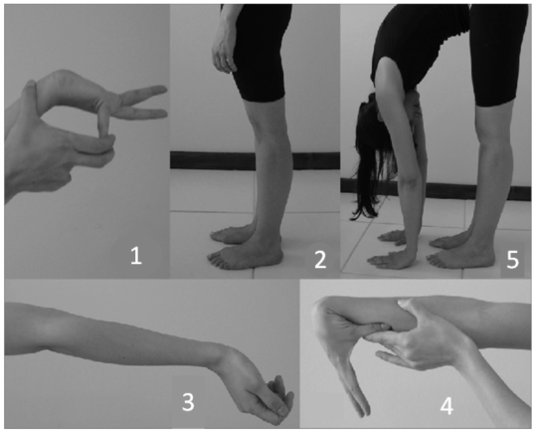
Figure 1. Beighton Score for General Hypermobility Test
Video: _X__ Yes _____No
https://www.youtube.com/watch?v=rmrjZKskW70

Equipment Required/Set-up: None
Procedure/Script:
For each of the following tests, first demonstrate and then have participant perform the test. All tests should be performed while standing; test both left and right sides, except for spine test.
After each demonstration, ask the participant, “Do you think you can perform this test?” If “Yes,” complete the test and proceed to the next joint.

1. 5th FINGER/‘PINKIES’
Rest palm of the hand and forearm on a flat surface with palm side down and fingers out straight. Can the fifth finger be bent/lifted upward at the knuckle to go back beyond 90 degrees? If yes, add one point for each hand.

2. KNEES
While standing, with knees locked (bent backwards as far as possible), does the PT notice any hyperextension in either knee? If yes, add one point for each side.

3. ELBOWS
With arms outstretched and palms facing upwards, does the elbow extend (bend too far) upwards more than an extra 10 degrees beyond a normal outstretched position? If yes, add one point for each side.

4. THUMBS
With the arm out straight, the palm facing down, and the wrist then fully bent downward, can the thumb be pushed back to touch the forearm? If yes, add one point for each thumb.

5. SPINE
Can participant bend forward and place the palms of the hands flat on the floor in front of your feet without bending your knees? If yes, add one point.

Please see next page for scoring.

Beighton Score for General Mobility Scoring

Was test attempted? _1. Yes _0. No.

Record results:
1. Passive hypertension of the fifth MCP joint beyond 90 degrees
Left _1. Yes _0. No. Right _1. Yes _0. No.

2. Passive hyperextension of the knee beyond 10 degrees
Left _1. Yes _0. No. Right _1. Yes _0. No.

3. Passive hyperextension of the elbow beyond 10 degrees
Left _1. Yes _0. No. Right _1. Yes _0. No.

4. Passive apposition of the thumb to the flexor aspect of the forearm
Left _1. Yes _0. No. Right _1. Yes _0. No.

5. Active forward flexion of the trunk with the knees fully extended so that the palms of the hands rest flat on the floor
Left _1. Yes _0. No. Right _1. Yes _0. No.

TOTAL score: ______ (sum of ‘Yes’ responses calculated electronically)

Comments:

Date (mm/dd/yyyy):
Visit Time Point:
Initials of completer:

References:
Juul-Kristensen B, Schmedling K, Rombaut L, Lund H, Engelbert RH. Measurement properties of clinical assessment methods for classifying generalized joint hypermobility-A systematic review. American Journal of Medical Genetics Part C, Seminars in Medical Genetics. 2017;175(1):116-147.

Kyndall L. Boyle; Philip Witt; Cheryl Riegger-Krugh. Intrarater and Interrater Reliability of the Beighton and Horan Joint Mobility Index. Journal of Athletic Training, 2003;38(4), 281-285.

